ASA Lay Language Paper Style Guide

General Information
- The Lay Language Paper (LLP) should be short and to the point. The goal is to post ‘bite-size’ pieces that readers can digest in a few minutes (>100 words, ideally 300-500 words). Start with a “hook,” a sentence that catches the reader’s attention and interest
- Keep language simple, our readers will not be familiar with most technical, jargony terms. This De-Jargonizer program can give you insights into how common the words you are using are in everyday media.
    - Readers will know words like “energy” or “wave,” and how to read plots and (simple) equations. LLPs should be accessible and fun, without compromising scientific accuracy.
    - Try to limit acronyms as much as possible unless they are standard in the field. When using the acronym for the first time, make sure to spell it out. For acronyms the researchers created during their study, it’s best to just write out the words each time.
- Don’t overload the paper with too many scientific concepts; simplify the story when necessary, while still staying faithful to the original research being presented.
- Make sure the post tells a good story! There should be transitions between each concept, and every paper should have a beginning, middle, and end.
    - A good story has a beginning (setting up a problem that needs to be solved), a middle (how we solved the problem) and an end (we’ve solved the problem; what lessons have we learned? What general insights have we gained?’). It may also be helpful to think about the typical story in a scientific paper, with a beginning (introduction), middle (methods), and end (conclusion).
- The LLP should start with the main point / thesis and then explain it — don’t save the punchline for the end or readers might never get there!
    - The general structure of your paper should follow the inverted pyramid of journalism structure in Figure 1 below. That is, the main question the paper answers and the general answer to that question should come relatively quickly. You’ll notice that is the exact opposite of a typical research paper.
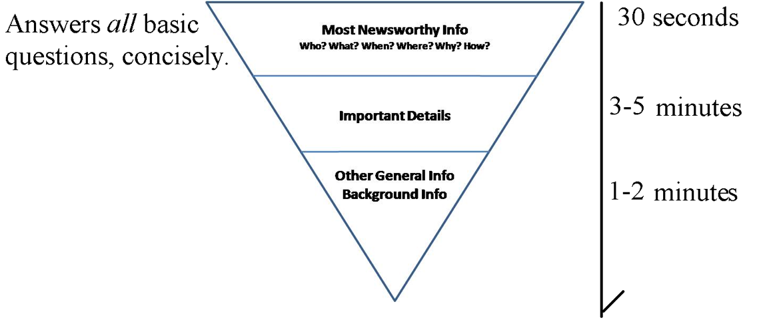
Figure 1 Svetlana Tkachenko, CC BY-SA 4.0, via Wikimedia Commons
- Include a few figures. Figures should make the results easier to understand. Avoid tables unless they add something that cannot be accomplished with figures.
    - Figures should always support and clarify the writing and be directly mentioned in the text.
- Formal citations should be avoided. Additional information can be made available as a footnote or as an in-text hyperlink.

Style Checklist
Before submitting your Lay Language Paper (LLP), please make sure you have completed everything on this checklist.

- A one sentence, self-explanatory title, which in most cases, should not be the same as your abstract title.
- At least one figure to support or clarify your writing
- The opening and closing sentences (and subtitle if relevant) are supported by the rest of the story
- Transitions exist between paragraphs and between concepts, ensuring that the flow is smooth
- The grammar and spelling are correct
- Same verb tense is used throughout (or at least the same tense is used throughout a given paragraph)
- Jargon is minimized as much as possible and all technical terms, abbreviations, acronyms, etc. are defined when first used
- Minimal abbreviations (i.e. use “for example,” not “i.e.”/“e.g.”)
- Limit passive voice (when possible, say “the researchers show that” instead of “it is shown that”)
- Additional information is given as footnotes or as in-text hyperlinks to the reference.
- All figures/images are attributed appropriately in the caption text: “Image courtesy of [SOURCE]” or “Image adapted from [AUTHOR’S] original paper.”
- All hyperlinks are in-text (i.e. “Information is available on the Acoustics Wikipedia Page” NOT “Information is available at https://en.wikipedia.org/wiki/Acoustics")

It is a good idea to write your paper in your word processor of choice and then copy and paste it into the online submission form.

Based on the Softbites Style Guide and PERbites Article Guidelines

